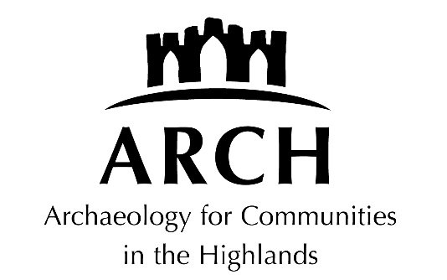

CHILD AND VULNERABLE ADULT POLICY

CHILD AND VULNERABLE ADULT PROTECTION POLICY STATEMENT

The following definitions apply to this document:

1. Board members: members appointed to ARCH board;
2. Employees/staff: paid individuals who undertake work for ARCH on behalf of the company;
3. Volunteers: unpaid individuals who help run events on the company’s behalf; and
4. Members of the public: members of the public who attend ARCH events.

Updated and approved: 2021, 2024

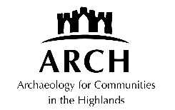

Child and Vulnerable Adult Protection Policy
for Archaeology for Communities in the Highlands

1. We recognise the importance of providing protection for children and vulnerable adults. A vulnerable adult is here defined as ‘an adult aged 16 or over who is unable to safeguard his or her personal welfare, property, or financial affairs, and is: in need of care and attention arising out of age or infirmity, or suffering from illness or mental disorder, or substantially handicapped by any disability’

2. We aim to ensure that any vulnerable people, whether children or vulnerable adults, are protected and kept safe from harm while they are with staff or volunteers in this organisation. In order to achieve this we will ensure our staff are carefully selected, screened, trained and supervised.

3. At any ARCH-sponsored event, there must be at least one ARCH employee or volunteer who has an Enhanced Disclosure certificate. No staff/volunteer without the Enhanced Disclosure certificate will be left unattended with children and vulnerable adults.

4. We will immediately remove from any contact with children or vulnerable adults any member of staff or volunteer whom we know or suspect to have caused harm to a child or vulnerable adult, or to have placed one at risk of harm and will follow the procedures described here below, which comply with the good practice and procedures required by the Highland Council’s guidelines (see below, Contacts and Resources.

5. We will ensure that all staff and volunteers involved in recruitment, training and supervision are aware of this policy and have received appropriate training and support to ensure its full implementation.

6. The Board will be responsible for this policy.

Procedure if abuse is suspected to have taken place within the organisation of ARCH and during an ARCH activity or event

10. The following procedure will be followed:
  - It will be the responsibility of any staff member or volunteer to share their concerns immediately with the designated line manager / nominated ARCH Board member / Chair of ARCH.
  - The designated line manager / nominated ARCH Board member / Chair of ARCH will be responsible for making sure that accurate records are kept, maintained and reviewed.
  - The designated line manager / nominated ARCH Board member / Chair of ARCH will immediately refer the matter to Highland Council Social Work and Police if a criminal offence has been alleged as appropriate. These will then determine how the matter will proceed and be responsible for the investigation of the matter.
  - Where interviewing and information gathering is required, it must be initiated within a maximum of 24 hours.

11. We believe that every child, regardless of age, and every vulnerable adult has at all times and in all situations a right to feel safe and protected from any situation or practice that would result in them being physically or psychologically damaged. In our organisation, if we have suspicions about a person’s physical, sexual or emotional well being, we will take action.

12. All volunteers and staff are encouraged to share concerns with their designated line manager / nominated ARCH Board member / Chair of ARCH. If the situation is clearly an urgent case, the child/vulnerable adult is too frightened to go home or we have very serious doubts about their safety, we will contact Social Work Services or Police immediately.

13. If our concerns are more general about a child’s/vulnerable adult’s welfare, then staff should discuss these with the line manager, who will then seek advice on how best to meet their needs. It is important that all volunteers and staff communicate concerns accurately. To this end, volunteers and staff will follow the procedures below:

1. Upon receipt of any information from a child/vulnerable adult or suspicions, it is necessary to make an accurate and detailed written record of what they have seen, heard or know, at the time the event occurs;

2. Share their concerns with their line manager/designated ARCH Board member for the organisation and agree what action to take;

3. Avoid asking any more questions than are necessary to clarify whether there is a concern. Always REFER to statutory services to undertake in depth INVESTIGATION of any suspicions or allegations of abuse.

14. If we have concerns we must act – it may be the final piece of the jigsaw that is needed to protect that child/vulnerable adult – believing that we may prevent further injury and harm.

Contacts and Resources

If you are concerned that a child might be at risk of harm, contact a member of the Family Team. Details of numbers are at https://hcpc.scot/help-advice-numbers/. The Highland Council Social Work Emergency telephone for out of office hours is 0808 175 3646 (Monday to Friday 5-9pm, all day on weekends and public holidays). Current contact details of appropriate staff are incorporated on a pdf download from Highland Council’s Care and Learning Services: http://www.highland.gov.uk/downloads/file/6180/childrens_services.
These may change in the future, and should be checked periodically.
At the time of writing, the Highland Council contact for concerns about vulnerable adults is 01349 886606 or 0808 175 3646 (our of hours)
Further information is on the Highland Council website: http://www.highland.gov.uk/info/1361/childcare_and_family_care/438/child_protection
Highland Council’s Child Protection Guidance and Toolkit for Community Groups in Highland is available on http://hcpc.scot/resources/
Highland Council’s Adult Support and Protection in Highland Inter-agency Procedures for the Implementation of the Adult Support and Protection (Scotland) Act 2007 is available on https://www.highland.gov.uk/downloads/file/6118/adult_support_and_protection_inter_agency_procedures

Child and Vulnerable Adult Protection Policy Statement
for Archaeology for Communities in the Highlands

We will:

- Have contact details of any known vulnerable unaccompanied adult involved with the organisation including relevant medical details.

- Ensure that for any events with unaccompanied children we have contact details, and the events are led by staff with enhanced PVG disclosure certificates.

- Treat everyone with respect.

- Remember that some issues are confidential.

- Provide an example we would wish others to follow.

- Where possible consider activities which involve more than one adult being present or at least within sight and hearing of others.

- Be aware that someone else might misinterpret our actions even if they are well-intentioned.

- Respect a person’s right to personal privacy.

- Provide time for children/vulnerable adult to talk to us.

- Encourage people to respect and care for others.

- Take action to stop any inappropriate verbal or physical behaviour.

- Have an organisation policy for collection of children after meetings have finished.

- Remember to REFER not INVESTIGATE any suspicions or allegations about abuse.

- Only share concerns and seeks support from those indentified in the organisation’s Child and Vulnerable Adult Protection Policy.

- Complete the vetting checklist.

ARCH
April 2019, approved July 2021, January 2024

